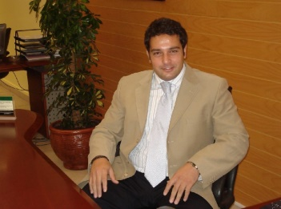

**Curriculum Vitae / CV**

***Dear sir / Madam,***

*It is with great interest, that i am forwarding my resume, for your kind Consideration.*

*My record of academic achievement, and professional career history, demonstrate attributes, to make me a valuable employee.*

*My Resume is enclosed, to provide you with details of my skills, and accomplishments, but i am certain, that a personal interview would more fully reveal my desire and ability, to contribute to your organization.*

*Thank you for your time and consideration, and please do not hesitate to contact me if you have any question:*

*My Mobile* ***+96176624355 (Lebanon) or*** *Email:*

***yehiaramzi@gmail.com***

*Looking forward to hear from you soon.*

*Sincerely Yours,*

*Ramzi Yehia*

***JOB OBJECTIVE:***

*To find a Challenging position, which I can utilize my special skills, education, and work experience, within a company, that allows for advancement and growth.*

***Personal Profile / Skills:***

* *Proficient in verbal and written English communication.*
* *Literate in computer applications (Microsoft word, Excel.)*
* *Self-Motivated and has the Ability to adapt to new Challenges and opportunities.*
* *Problems solving attitude and team builder talent.*

***WORK EXPERIENCES***

***1/ 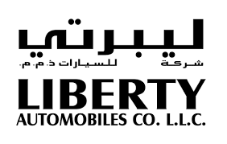 LIBERTY AUTOMOBILES COMPANY, U.A.E***

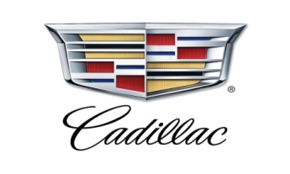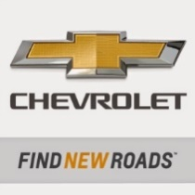 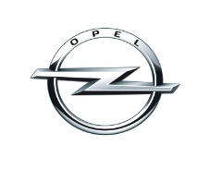

***Liberty Automobiles is the official dealer of Cadillac, Chevrolet and Opel Luxury Brands Cars in UAE, with well trained and professional Employee staff, and it has long and successful history, of 40 years of selling cars, and solid record, of customer’s satisfaction environment.***

***Duties and Responsibilities***

***Position: Division Sales Manager :***

***Oct’ 2010 – July ‘2017 : (7 Years)***

* *Guide, Motivate and Manage ( 5) showrooms, with daily activities , follow up with sales Seniors , to achieve daily targets , by solve*
* *problems , support selling prices, and give additional attention to customers’ requests. And I set and evaluate Several Key Performance Indicators (KPI’s) and Customer Sales Index (CSI) for both Sales and Logistic Dept.*
* *Set plans on strategic level, established and control a systemized and professional environment, and delegate authorities, for better achieving of results, and Revenue management of stock.*
* *Increased sales Numbers year after year, by following several techniques like open doors policy,*

*Give Support to new showroom sales, by offering the*

*Highest trade -in values, to liberty brands (Cadillac in Particular, Chevrolet and Opel), in order to create customer Brand trust.*

* *Competent in ability, to coach and lead a sales team, through my knowledge in modern vehicle construction, features, selling techniques, and customer care. Also ensure that the budgeted target for showrooms is achieved in volume and profit.*
* *Attends several professional training programs ,with General Motors Middle East, and make sure to apply in our daily functions,*

*Such as maximize experience of demo cars drive, monitor demo to sales ratio, ( PDI ) process to ensure highest level of customer satisfaction.*

* *Develop, implement and measure marketing programs, in order to increase revenue, through marketing initiatives,(set plan of 2 month with Middle East General Motors Office to liquidate 15 % of the stock throughout this campaign only ).*
* *Train and hire quality staff, to drive Vehicles Division to maximum level of Productivity, deal with critical problems, issues, and ensure prompt action is taken on time.*
* *Develop effective monitoring, and evaluation plans, and interact regularly with existing customers, to establish profitable relationship, and determine their future requirements.*
* *Prepares presentations about the company products.*
* *Build long-term relationships with the clients, by always giving the personalized service, they deserve, in Coordination With (CRM ) Dept.*
* *Ability to gather data, compiles information, and prepares reports.*
* *Review and analyze feedback, to establish courses, which appear to provide most benefit to my sales team.*
* *Prepare performance evaluation and appraisal reports, to assess subordinates productivity, progress, and identifies training needs of team members, to improve efficiency, and ensure conformity with standard procedures and practices.*
* *Approve repair orders, by describing symptoms, problems, and causes discovered, as well as repairs, services required, and*

*Finally approve stock display plans inside showrooms, as per the international standards of General motors.*

***2/ ALI & SONS AUTOMOBILES Co., U.A.E***

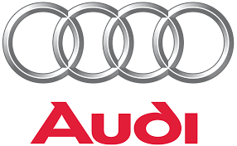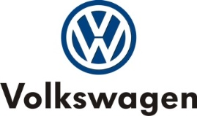 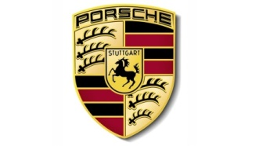

***Ali and Sons Automobiles is the Official dealer of Audi, VW, and Porsche luxury brands car in Abu-Dhabi, U.A.E***

***Duties and responsibilities:***

***Position : Showroom In-charge :***

***April’ 2004 – March ‘2009 ( 5 Years).***

* *Plan & control day to day work towards sales, customer inquiries/complaints and paper works.*
* *Make sure that the general images of the car brands are secured,*

*Have knowledge of principles, and processes for providing customer’s personal services, this includes customer needs assessment, meeting quality standards for services, and evaluation of customer satisfaction.*

* *Train & control the activities of sales and administration staff,*

*Analyzes & study market trend, in order to keep high level of performance.*

* *Ability to lead, manages, and directs professional teams.*
* *Ability to set plans strategic objectives, and measurement framework of key performance indicators (KPI’s) of the sales team.*
* *Team player, with strong analytical, project management skills,*

*Organized, detail oriented and flexible individual, who works well with deadlines.*

* *Develop effective monitoring, and evaluation plans.*

*Prepares presentations, about the company products, and*

*Build long-term relationships with the clients, by always giving clients the personalized service they deserve.*

***Seminars and Training:***

*Completed successfully of many training Courses:*

***(2011, 2012, 2013, 2014 , 2015, 2016 and 2017 )***

* *Leadership Courses Modules 1 , 2 , 3 by General Motors*

*Middle East Academy (GM ) , 2015, 2016.*

* *Certificates with General Motors international Academy.*
* *Certificates with Audi Middle East Academy.*

***EDUCATION:***

***Bachelor Degree / Science of Administration and Politics.***

***Lebanese University- Beirut (1997 – 2001).***

***Personal Background:***

***Nationality: Lebanese***

***Civil Status: Married***

***I hereby declare, that the above information is true according to my Knowledge, and available upon Request.***